**LAB 6 : Binary Tree**

## **[CO2]**

## **Instructions for students:**

* Complete the following methods.
* You may use Java / Python to complete the tasks.
* DO NOT CREATE a separate folder for each task just follow the given template.
* If you are using **JAVA**, then follow the [**Java Template**](https://drive.google.com/file/d/1DsWb35odE0q2Dm_BbPGXiCM7AoGqiS9n/view?usp=sharing).
* If you are using **PYTHON**, then follow the [**Python Template**](https://colab.research.google.com/drive/1J6HwmLdxAt5YvuX0740J3ExTj7CuWlwC).

## **NOTE:**

## **YOU CANNOT USE ANY OTHER DATA STRUCTURE OTHER THAN ARRAY UNLESS MENTIONED IN THE QUESTION.**

## **YOUR CODE SHOULD WORK FOR ANY VALID INPUTS.**

## **Python List, Negative indexing and append() is STRICTLY prohibited**

**TOTAL MARKS: 5*6=30**

## 

## Mirror Tree:

Given a binary tree, convert it into its mirror.

Sample Input:

10

/ \

20 30

/ \

40 60

Sample Output:

10 10

/ \ Mirror / \

20 30 —> 30 20

/ \ / \

40 60 60 40

Inorder Traversal of mirror: 30 10 60 20 40

## 

## Level Min:

Given a binary tree, find the smallest value in each level.

Sample Input: [For **Python** You can use a dictionary here]

4

/ \

9 2

/ \ \

3 -5 7

Sample Output: 4 2 -5

Explanation:

There are 3 levels in the tree

Level 0: {4}, min= 4

Level 1: {2, 9}, min= 2

Level 2: {7, 3, -5}, min = -5

## 

## Sum of Nodes:

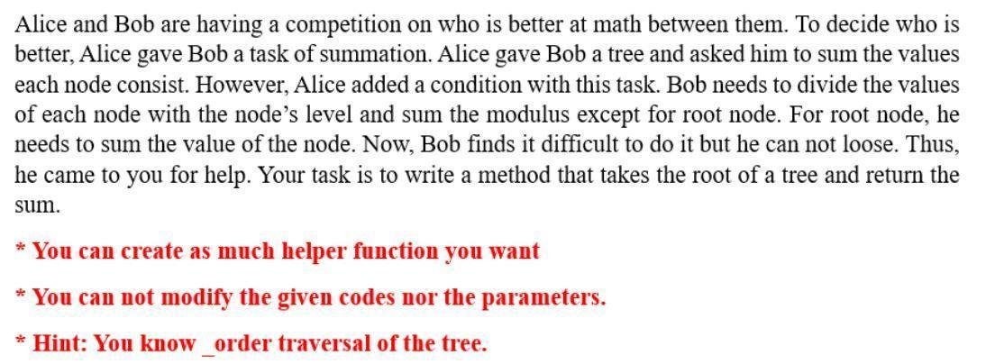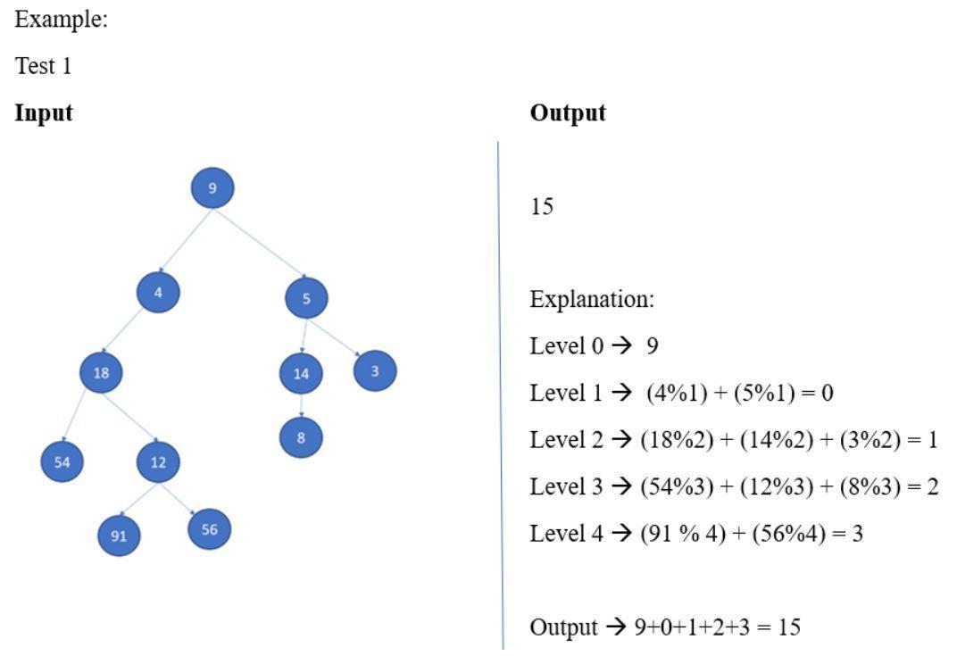

1. Swap Children Nodes:

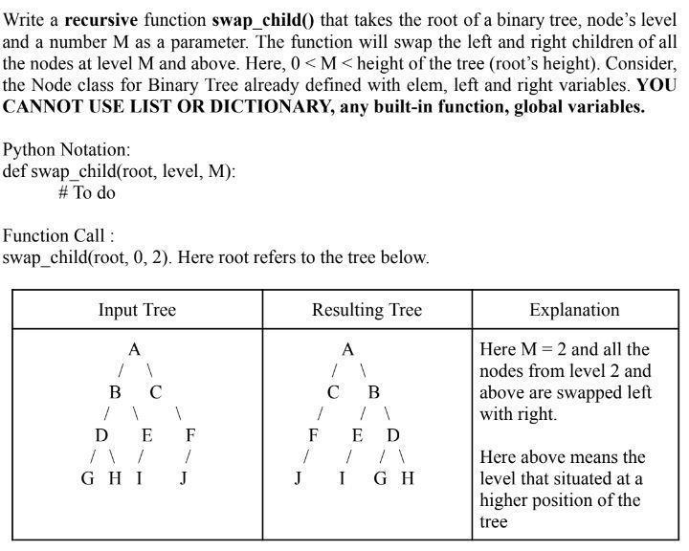

## Subtraction of Nodes:

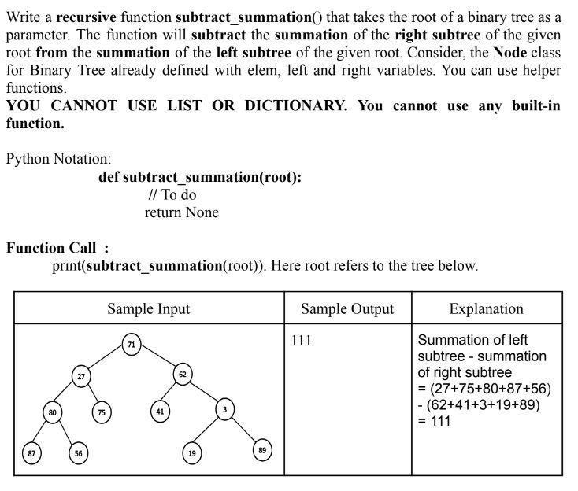

## 

## 

## 

## Difference of Level Sum

Given a Binary Tree, Write a function that finds the difference between sum of all nodes present at odd and even levels in a binary tree, i.e. sum of all odd level nodes - sum of all even level nodes.

| Sample Input: | Sample Output | Explanation |
| --- | --- | --- |
|  | 4 | -1+2+3-4-5-6+7+8 = 4 |